Show work for full credit. Include MultiSIM screenshots where indicated.
- Consider the parallel inductive reactive circuit below. Calculate the following: (Express all answers in magnitude/phase angle form)
  - Zeq
  - I_{T}
  - X_{L2}
  - X_{L1}
  - I_{R1}
  - I_{R2}
  - I_{L1}
  - I_{L2}
Parallel Inductive Circuit:
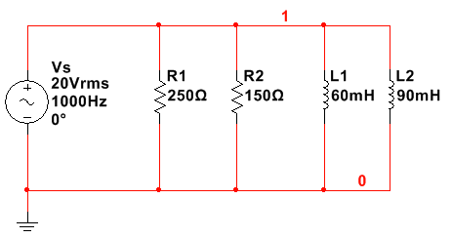
Consider the series RC circuit below:
- Assume C1 is completely discharged with S1 in the position shown. If S1 is moved to the top position, how long will it take for the capacitor voltage to reach
  - 3V
  - 6V
  - 15V
  - 20V
- Assume that C is completely discharged with S1 in the position shown. If S1 is moved to the top position, how much is the resistor voltage at the following time intervals?
  - t = 0 s
  - t = 4.5 ms
  - t = 10 ms
  - t = 15 ms
  - t = 25 ms
Series RC Circuit:
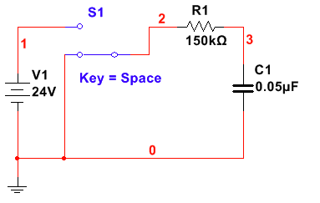
• Analyze the RLC circuit below to determine the following (include both polar and complex forms where applicable):
- Z_{eq}
- I_{T}
- I_{R1}
- I_{L1}
- Real Power (Watts)
- Reactive Power (VARs)
- Apparent Power (VAs)
- Power Factor
• Construct the circuit in MultiSIM and run a Single Frequency Analysis to confirm your calculations for the phasor values in part 3. Capture a screenshot of the analysis for both Magnitude/Phase (polar) and Real/Imaginary (complex).
• Measure the real power of the circuit and the power factor using a watt meter. Capture a screenshot of the watt meter readings.
RLC Circuit:
